SOCIAL STUDIES - 2003 (Set I— Outside Delhi)
Q. 1. Describe any two characteristics of the temple architecture under the Hoysala ruler. 2
Q. 2. Write two characteristics of the paintings of the Ajanta caves. 2
Q. 3. Study the diagram given below and answer the questions that follow: 2
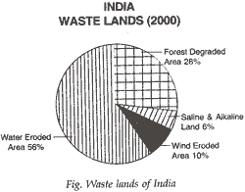
(a) Which two categories show the highest and the lowest percentage of wasteland respectively?
(b) Write an important measure each to avoid land degradation in these two types of categories.
(The following question is for Blind Candidates only in lieu of Q. No. 3)
Write four important measures taken by the Government to avoid land degradation. ½ x4=2
Q. 4. What is watershed development? Write any two important considerations which a water shed development plan must take? 1+1=2
Q. 5. What do you understand by inland waterways? Name two national inland water ways. 1+½+½2
Q. 6. Which city is called the electronic capital of India? Write three points to stress the importance of electronic industry in present times. 2
Q. 7. In which year the real growth of fertilizer industry started and where? Name a fertilizer which India needs to import and one in which India is self sufficient. 2
Q. 8. Write two characteristics of mountain soils. 2
Q. 9. What made India’s public sector so large? 2
Q. 10. What is fossil fuel? Who are the biggest users of fossil fuel? 2
Q. 11. What is the ultimate purpose of development? 2
Q. 12. “Caste system is a great hindrance in the working of Indian democracy” Explain. 2
Q. 13. Differentiate between political equality and social equality. 4
Q. 14. Describe three steps taken by Raja Rammohan Roy to modernise the Indian society. 4
Q. 15. What were the major shortcomings of the British educational policy in India in the 19 century? 4
Or
Explain any two factors which helped in the growth of national consciousness in India in the 19th century. 4
Q. 16. (a) What are badlands? Name two major States which experience large scale gully erosion. 1+1=2
(b) Why do we need to do resource planning? Name the stages of resource planning. 2
Q.17. Slate three important objectives of planning in India, by giving one example of each. 4
Q. 18. Explain the importance of foreign trade in the economic growth of India giving three suitable examples. 4
Q.19. Define terrorism and enumerate its main characteristics. 4
Q. 20. Describe, with examples, the policy of the Indian Nationalist Movement towards developments in the world in the 1930s. 6
Q. 21. Explain in detail four types of pollution created by industries. Also write four ways to control environmental degradation caused by industries. 4+2=6
Or
(a) Explain three sets of factors, which affect the distribution pattern of the railway network in the country.
(b) Write any three points which speak about the qualitative improvement in railways. 3+3=6
Q. 22. Write three characteristic features (points) of each of the following:
(a) Main features of Indian agriculture
(b) Intensive agriculture.
(c) Importance of forests.
(d) Canal irrigation 1½x4=6
Or
Discuss India’s position regarding her food needs in the coming years.
Q. 23. Write about the silk textile industry of India under the following heads:
(a) Varieties of silk
(b) Three major States which produce 9/10 of the production and name two major silk manufacturing centres of each of these States.
(c) Two continents, the countries of which have great demand for Indian silk.
Q. 24. Explain four important steps taken by the Government of India to promote large scale industries in India. 6
Q. 25. What efforts have been made by India to maintain cordial relations with Pakistan? 6
Q. 26. Discuss corruption as a social evil and mention various measures taken by the Government of India to check it. 6
Or
Mention different types of disabilities. Name various legislations enacted in India, India, which take care of the disabled. 6
Q. 27. (a) On the given outline map of India mark alongwith their years any two of the following: 2
I. The Congress session where the Civil Disobedience Movement was launched.
II. City where the Jallianwala Bagh Massacre took place.
III. City where the Quit India Resolution was passed.
(b) On the given outline map of India, A, B and C features are marked. Identify the features and write their names correctly in the space provided (read the legend carefully).
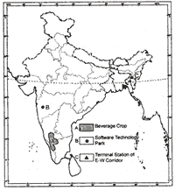
(c) On the given outline map of India locate and label the features given below:
I. First iron and steel industry of Private Sector
II. Pench-kanhan coalfield.
III. Major seaport of Karnataka.
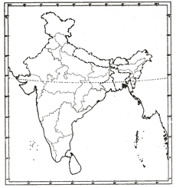
(The following question is for Blind Candidates only in lieu of Q. No. 27)
(a) Where is first Private Sector iron and steel centre situated? 1
(b) In which State are Pench-kanhan coal fields situated? 1
(c) Which is the major seaport of Karnataka? 1
(d) Which beverage crop is grown in Kerala and Karnataka? 1
(e) Name a city with a software technology park of Maharashtra. 1
(f) Name one terminal station of E-W corridor. 1
(g) Mention two chief features of the Gandhi Irwin Pact. 2

